CISC7204 – Data Science and Data Visualization

Assignment 1 (Preliminary Project Proposal)

Labor-market Value of Higher Education in Macao: A Data-Driven Analysis of Correlation between Education, Employment, and Income (from 2014 to 2024)

Region: Macao Special Administrative Region, China
Domain Category: Education, Labor Market, and Economy

Students
HO IOK LAM (MC643103)
CHENYANG XU (MC566811)

- Introduction
Higher education is generally regarded as an important pathway for improving employment opportunities and increasing economic returns. However, with the expansion of higher education and the transformation of Macao’s economic structure, it is important to examine whether higher education continues to provide substantial advantages in the labour market.
To investigate the relationship between education, employment, and income in Macao over the past decade, this project seeks to answer the following research question: “Did the labour-market value of higher education in Macao show proportional growth from 2014 to 2024?” To address this question, we will collect relevant data published by the Macao Government and apply the data cleaning, preparation, and visualization techniques learned in CISC7204. Based on the analysis of these data, we aim to identify trends in the labour-market outcomes associated with higher education and draw conclusions regarding the changes in its value over the period from 2014 to 2024.

- Purpose
This project aims to investigate the relationship between the expansion of higher education, employment outcomes, and changes in income in Macao through data-driven analysis and visualization. Rather than evaluating the value of higher education solely from the perspective of the number of graduates, the project adopts a multidimensional approach that considers higher education expansion, employment performance, unemployment rates, and income growth. In addition, major exogenous factors, such as the COVID-19 pandemic, will be taken into consideration to examine their potential effects on Macao’s socioeconomic conditions and labour market.
The project will collect official datasets from the Statistics and Census Service (DSEC) and the Education and Youth Development Bureau (DSEDJ). By integrating indicators related to education, the labour market, and economic conditions, the project aims to provide evidence-based insights into whether higher education has continued to generate positive labour-market outcomes in Macao over the study period.
To investigate the relationship between higher education and labour-market outcomes in Macao from 2014 to 2024, this project will address the following sub-questions:
- How have the number and proportion of highly educated workers in Macao changed over the period from 2014 to 2024?
- To what extent has the expansion of higher education been associated with improvements in employment outcomes?
- How have employment and income trends varied across different industries in Macao?
- How have major economic events, such as the COVID-19 pandemic, affected employment and income trends in Macao?

- Tasks
The following main tasks will be completed at different stages of the project:
No. | Task | Details
1 | Data Collection | The project will collect official datasets from DSEC and DSEDJ, including employment statistics, unemployment statistics, income indicators, CPI data, education statistics, and higher education statistics.
2 | Data Cleaning and Preparation | The collected datasets will be processed using Python in Jupyter Notebook. Data cleaning procedures will include handling missing values, checking inconsistent formats, standardizing variables, and preparing datasets for analysis.
3 | Feature Construction and Analysis | The project will construct useful indicators such as higher education employment ratio, graduate growth rate, unemployment indicators, and inflation-adjusted real income. Statistical analysis will be performed to identify trends and relationships.
4 | Data Visualization | Several visualizations will be created, including time-series charts, comparison charts, scatter plots, and heatmaps. These visualizations will help explain changes in education supply, employment outcomes, and income returns.

- Dataset Sources
Statistics and Census Service (DSEC) and Education and Youth Development Bureau (DSEDJ) have published data in annual base or quarter base on their official websites, we can collect those reliable data for this project. The data including but not limited to the followings.
  - Dataset Source 1: Statistics and Census Service (DSEC), Macao SAR Government
- DSEC Time Series Database: https://www.dsec.gov.mo/ts/#!/step1/zh-MO; https://www.dsec.gov.mo/ts/#!/step2/zh-MO (see “CISC7204-Assgn01-StudentID-PreliminaryProjectProposal_Dataset01_ENG - as of 20260915” in the submission folder)
- Consumer Price Index (CPI): https://www.dsec.gov.mo/timeseriesdatabase.aspx?keyindicatorid=43&lang=zh-MO
  - Dataset Source 2: Education and Youth Development Bureau (DSEDJ), Macao SAR Government
- Higher Education Statistics: https://portal.dsedj.gov.mo/webdsejspace/internet/Inter_main_page.jsp?id=700798&

- Justification for Visualization
In this project, data visualization techniques will be employed to illustrate changes in key indicators, such as employment earnings trends across industries, the educational attainment of employed residents, and median monthly employment earnings. We will employ a range of figures and graphical representations, including line charts, stacked charts, and scatterplot matrices, to directly address the research questions and examine the relationship between the expansion of higher education and labour-market outcomes.
Time-series visualizations will be used to illustrate changes in the number of higher education graduates and median monthly employment earnings over time, as shown in Figure 1. Comparative employment charts will be used to examine differences in employment outcomes across educational attainment groups and assess whether higher education is associated with more favourable employment conditions.
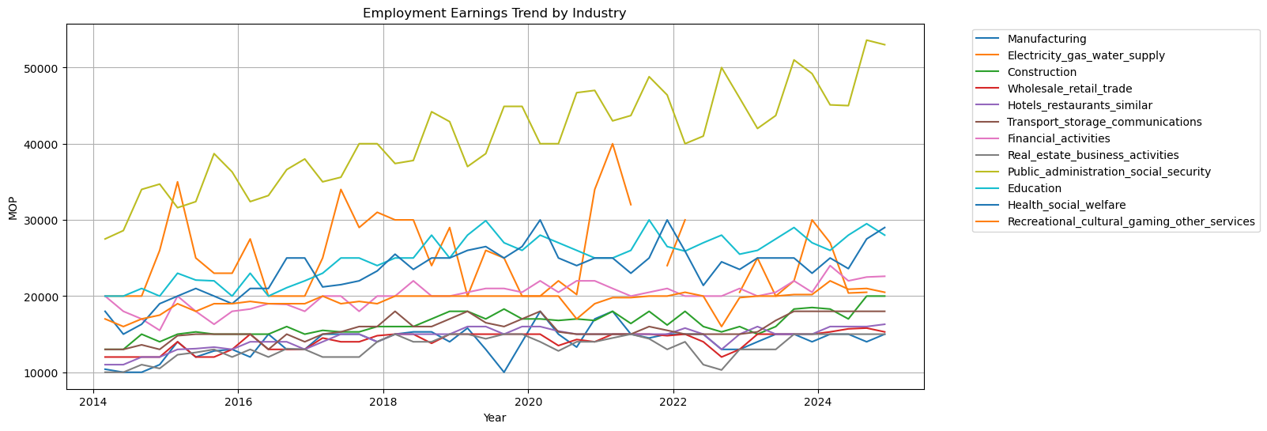
Figure 1 Employment Earnings Trend by Industry (2014 - 2024)
Furthermore, income trend visualizations, combined with Consumer Price Index (CPI) adjustments, will help distinguish real changes in income from those attributable to inflation. By integrating indicators such as the proportion of employed residents with higher education, employment performance, and economic returns, the proposed visualizations will provide a comprehensive assessment of whether higher education continues to generate labour-market value in Macao.

- Project Criteria for Success
The success of this project will be evaluated based on data quality, analytical rigor, visualization quality, and reproducibility. The project will use official datasets from relevant Macao government departments and apply appropriate procedures for data cleaning, integration, and preparation. The resulting visualizations should clearly communicate trends, patterns, and relationships between higher education, employment, and income, with appropriate titles, labels, units, and data sources.
A complete Jupyter Notebook will be developed to document the research workflow, including data acquisition, cleaning, transformation, analysis, and visualization. The analysis will integrate indicators of higher education expansion, employment outcomes, income trends, and relevant economic factors, including the potential effects of major events such as the COVID-19 pandemic. The final results should provide evidence-based insights into whether the labour-market outcomes associated with higher education in Macao changed between 2014 and 2024. The analysis will distinguish between correlation and causation and acknowledge the limitations of using observational data when interpreting the relationships identified.

- Project Collaboration
If completed as a pair project, responsibilities will be divided according to different data areas. Below is the proposed work allocation of this pair project
Students | HO IOK LAM (MC643103) | CHENYANG XU (MC566811)
Roles | Project Coordinator  Project Progress Tracker  Project Liaison  Project Scribe | Project Progress Tracker  Project Scribe
Missions | Research Design  Data Collection  Data Cleaning, Visualisation and Analysis (Question 1 – 4)  Report Writing | Data Organisation  Data Cleaning, Visualisation and Analysis (Question 2 – 3)  Report Writing
Both members will participate in research design, data verification, interpretation of results, report preparation, and final presentation development.

- Expected Final Deliverables
The final project will include the followings:
- A project report;
- Cleaned datasets in CSV/XLSX format;
- Jupyter Notebooks (with visualization results, and an evidence-based discussion of the changing labour-market value of higher education in Macao).

